
DATA STRUCTURE

Lab Assignment 1
Name: Hasnat Gul
Regn No: FA25-BCS-030
Date: 5-10-2026

Lab task 1;
#include <iostream>
using namespace std;
struct Node
{
int data;
Node* next;
};
void insertEnd(Node*& head, int value)
{
Node* newNode = new Node;
newNode->data = value;
newNode->next = NULL;
if (head == NULL)
{
head = newNode;
return;
}
Node* temp = head;
while (temp->next != NULL)
{
temp = temp->next;
}
temp->next = newNode;
}
void display(Node* head)
{
Node* temp = head;
while (temp != NULL)
{
cout << temp->data << " ";
temp = temp->next;
}
cout << endl;
}
// Display in reverse WITHOUT changing links
void displayReverse(Node* head)
{
if (head == NULL)
return;
displayReverse(head->next);
cout << head->data << " ";
}
int main()
{
Node* head = NULL;
insertEnd(head, 10);
insertEnd(head, 20);
insertEnd(head, 30);
insertEnd(head, 40);
insertEnd(head, 50);
cout << "Original List: ";
display(head);
cout << "Reverse Display: ";
displayReverse(head);
return 0;
}
Output
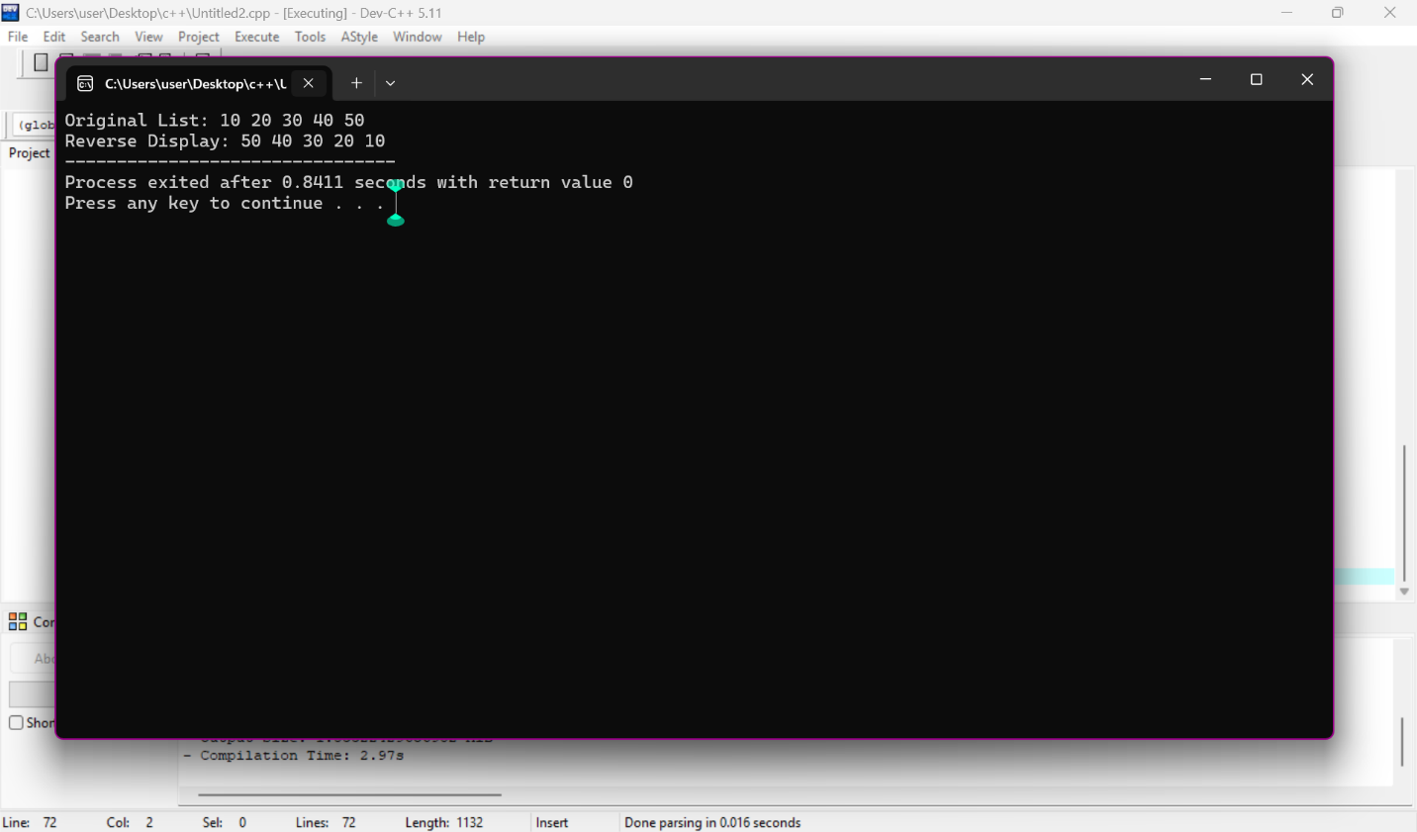

Lab task 2
#include <iostream>
using namespace std;

struct Node
{
int data;
Node* next;
};

void insertEnd(Node*& head, int value)
{
Node* newNode = new Node;
newNode->data = value;
newNode->next = NULL;

if (head == NULL)
{
head = newNode;
return;
}

Node* temp = head;

while (temp->next != NULL)
{
temp = temp->next;
}

temp->next = newNode;
}

void display(Node* head)
{
Node* temp = head;

while (temp != NULL)
{
cout << temp->data << " ";
temp = temp->next;
}

cout << endl;
}

void reverseList(Node*& head)
{
Node* previous = NULL;
Node* current = head;
Node* nextNode = NULL;

while (current != NULL)
{
nextNode = current->next;
current->next = previous;
previous = current;
current = nextNode;
}

head = previous;
}

int main()
{
Node* head = NULL;

insertEnd(head, 10);
insertEnd(head, 20);
insertEnd(head, 30);
insertEnd(head, 40);

cout << "Original List: ";
display(head);

reverseList(head);

cout << "Reversed List: ";
display(head);

return 0;
}
Output
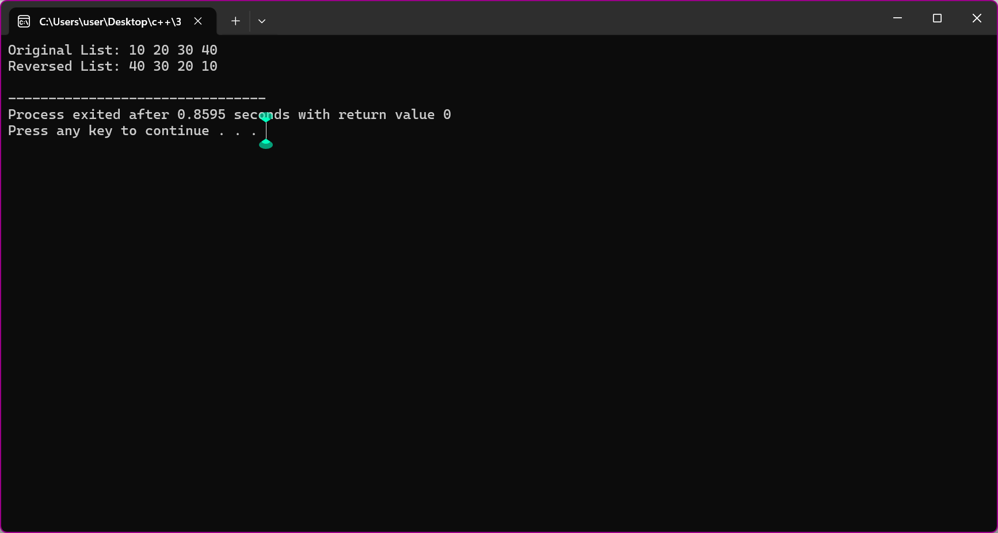
Lab task 3
#include <iostream>
using namespace std;

struct Node
{
int data;
Node* next;
};

void insertEnd(Node*& head, int value)
{
Node* newNode = new Node;
newNode->data = value;
newNode->next = NULL;

if (head == NULL)
{
head = newNode;
return;
}

Node* temp = head;

while (temp->next != NULL)
{
temp = temp->next;
}

temp->next = newNode;
}

void display(Node* head)
{
Node* temp = head;

while (temp != NULL)
{
cout << temp->data << " ";
temp = temp->next;
}

cout << endl;
}

void removeDuplicates(Node* head)
{
Node* current = head;

while (current != NULL)
{
Node* previous = current;
Node* temp = current->next;

while (temp != NULL)
{
if (temp->data == current->data)
{
previous->next = temp->next;
delete temp;
temp = previous->next;
}
else
{
previous = temp;
temp = temp->next;
}
}

current = current->next;
}
}

int main()
{
Node* head = NULL;

insertEnd(head, 10);
insertEnd(head, 20);
insertEnd(head, 10);
insertEnd(head, 30);
insertEnd(head, 20);
insertEnd(head, 40);

cout << "Original List: ";
display(head);

removeDuplicates(head);

cout << "After Removing Duplicates: ";
display(head);

return 0;
}
Output
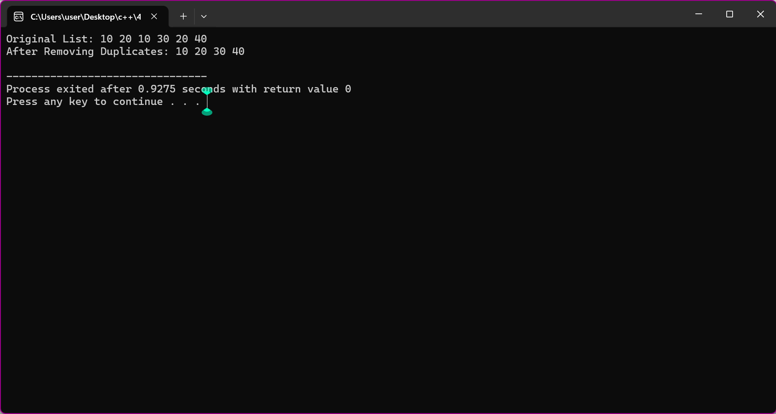

Lab task 4
#include <iostream>
using namespace std;

struct Node
{
int data;
Node* next;
};

bool detectLoop(Node* head)
{
Node* slow = head;
Node* fast = head;

while (fast != NULL && fast->next != NULL)
{
slow = slow->next;
fast = fast->next->next;

if (slow == fast)
{
return true;
}
}

return false;
}

int main()
{
Node* head = new Node;
Node* second = new Node;
Node* third = new Node;
Node* fourth = new Node;

head->data = 10;
head->next = second;

second->data = 20;
second->next = third;

third->data = 30;
third->next = fourth;

fourth->data = 40;

// Creating loop
fourth->next = second;

if (detectLoop(head))
cout << "Loop exists in the linked list.";
else
cout << "No loop exists.";

return 0;
}
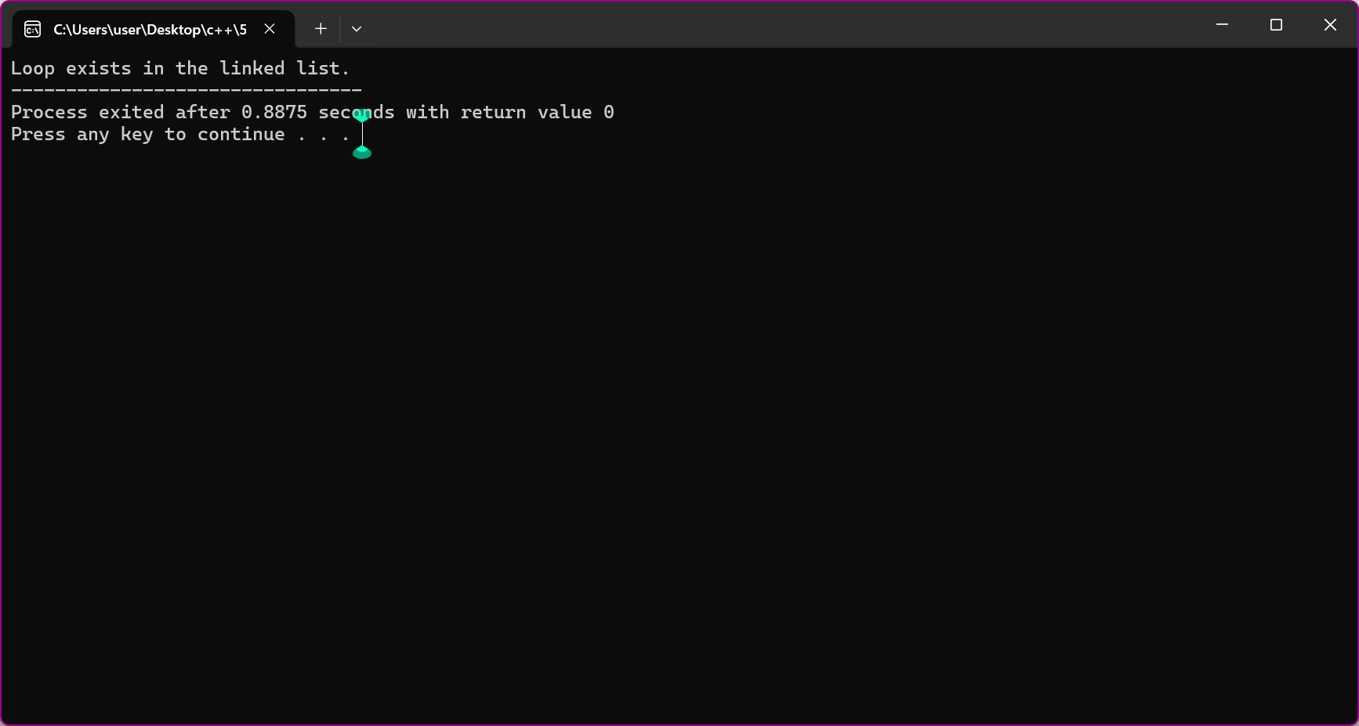

Lab task 5
#include <iostream>
using namespace std;

struct Node
{
int data;
Node* next;
};

void insertEnd(Node*& head, int value)
{
Node* newNode = new Node;
newNode->data = value;
newNode->next = NULL;

if (head == NULL)
{
head = newNode;
return;
}

Node* temp = head;

while (temp->next != NULL)
{
temp = temp->next;
}

temp->next = newNode;
}

void display(Node* head)
{
while (head != NULL)
{
cout << head->data << " ";
head = head->next;
}

cout << endl;
}

Node* findMiddle(Node* head)
{
if (head == NULL)
return NULL;

Node* slow = head;
Node* fast = head;

while (fast->next != NULL && fast->next->next != NULL)
{
slow = slow->next;
fast = fast->next->next;
}

return slow;
}

int main()
{
Node* head = NULL;

insertEnd(head, 10);
insertEnd(head, 20);
insertEnd(head, 30);
insertEnd(head, 40);
insertEnd(head, 50);
insertEnd(head, 60);

cout << "List: ";
display(head);

Node* middle = findMiddle(head);

cout << "Middle Node: " << middle->data;

return 0;
}
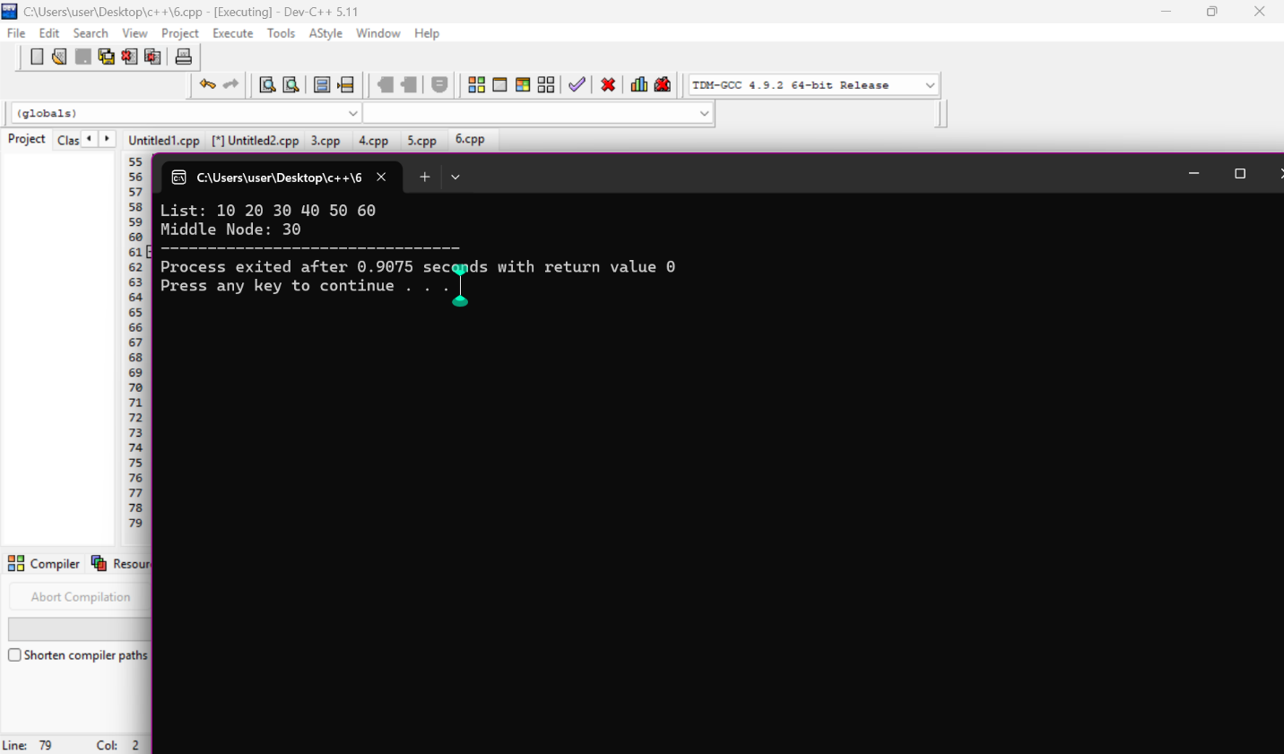
Lab task 6
#include <iostream>
using namespace std;

struct Node
{
int data;
Node* next;
};

void insertEnd(Node*& head, int value)
{
Node* newNode = new Node;
newNode->data = value;
newNode->next = NULL;

if (head == NULL)
{
head = newNode;
return;
}

Node* temp = head;

while (temp->next != NULL)
{
temp = temp->next;
}

temp->next = newNode;
}

void display(Node* head)
{
while (head != NULL)
{
cout << head->data << " ";
head = head->next;
}

cout << endl;
}

void separateEvenOdd(Node*& head)
{
Node* evenStart = NULL;
Node* evenEnd = NULL;
Node* oddStart = NULL;
Node* oddEnd = NULL;

Node* current = head;

while (current != NULL)
{
Node* nextNode = current->next;
current->next = NULL;

if (current->data % 2 == 0)
{
if (evenStart == NULL)
{
evenStart = current;
evenEnd = current;
}
else
{
evenEnd->next = current;
evenEnd = current;
}
}
else
{
if (oddStart == NULL)
{
oddStart = current;
oddEnd = current;
}
else
{
oddEnd->next = current;
oddEnd = current;
}
}

current = nextNode;
}

if (evenStart != NULL)
{
head = evenStart;
evenEnd->next = oddStart;
}
else
{
head = oddStart;
}
}

int main()
{
Node* head = NULL;

insertEnd(head, 1);
insertEnd(head, 2);
insertEnd(head, 3);
insertEnd(head, 4);
insertEnd(head, 5);
insertEnd(head, 6);
cout << "Original List: ";
display(head);
separateEvenOdd(head);
cout << "Even followed by Odd: ";
display(head);
return 0;
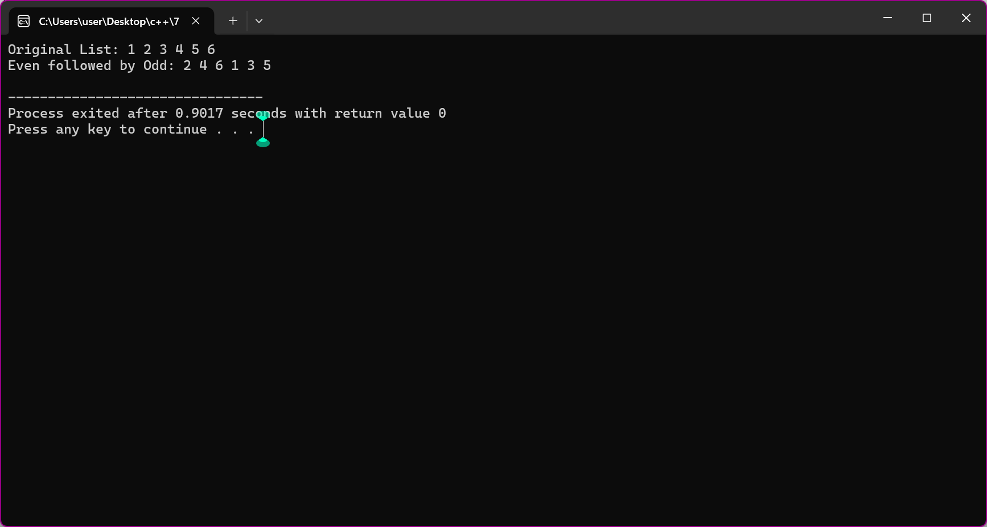
}

LAB task 7
#include <iostream>
using namespace std;

struct Node
{
int data;
Node* next;
};

void insertEnd(Node*& head, int value)
{
Node* newNode = new Node;
newNode->data = value;
newNode->next = NULL;

if (head == NULL)
{
head = newNode;
return;
}

Node* temp = head;

while (temp->next != NULL)
{
temp = temp->next;
}

temp->next = newNode;
}

void display(Node* head)
{
while (head != NULL)
{
cout << head->data << " ";
head = head->next;
}

cout << endl;
}

Node* reversePart(Node* head)
{
Node* previous = NULL;
Node* current = head;

while (current != NULL)
{
Node* nextNode = current->next;
current->next = previous;
previous = current;
current = nextNode;
}

return previous;
}

void reverseHalves(Node*& head)
{
if (head == NULL || head->next == NULL)
return;

Node* slow = head;
Node* fast = head;

while (fast->next != NULL && fast->next->next != NULL)
{
slow = slow->next;
fast = fast->next->next;
}

Node* secondHalf = slow->next;
slow->next = NULL;

Node* firstHalf = reversePart(head);
secondHalf = reversePart(secondHalf);

head = firstHalf;

Node* temp = firstHalf;

while (temp->next != NULL)
{
temp = temp->next;
}
temp->next = secondHalf;
}
int main()
{
Node* head = NULL;
insertEnd(head, 1);
insertEnd(head, 2);
insertEnd(head, 3);
insertEnd(head, 4);
insertEnd(head, 5);
insertEnd(head, 6);
insertEnd(head, 7);
insertEnd(head, 8);
cout << "Original List: ";
display(head);
reverseHalves(head);
cout << "After Reversing Halves: ";
display(head);
return 0;
}

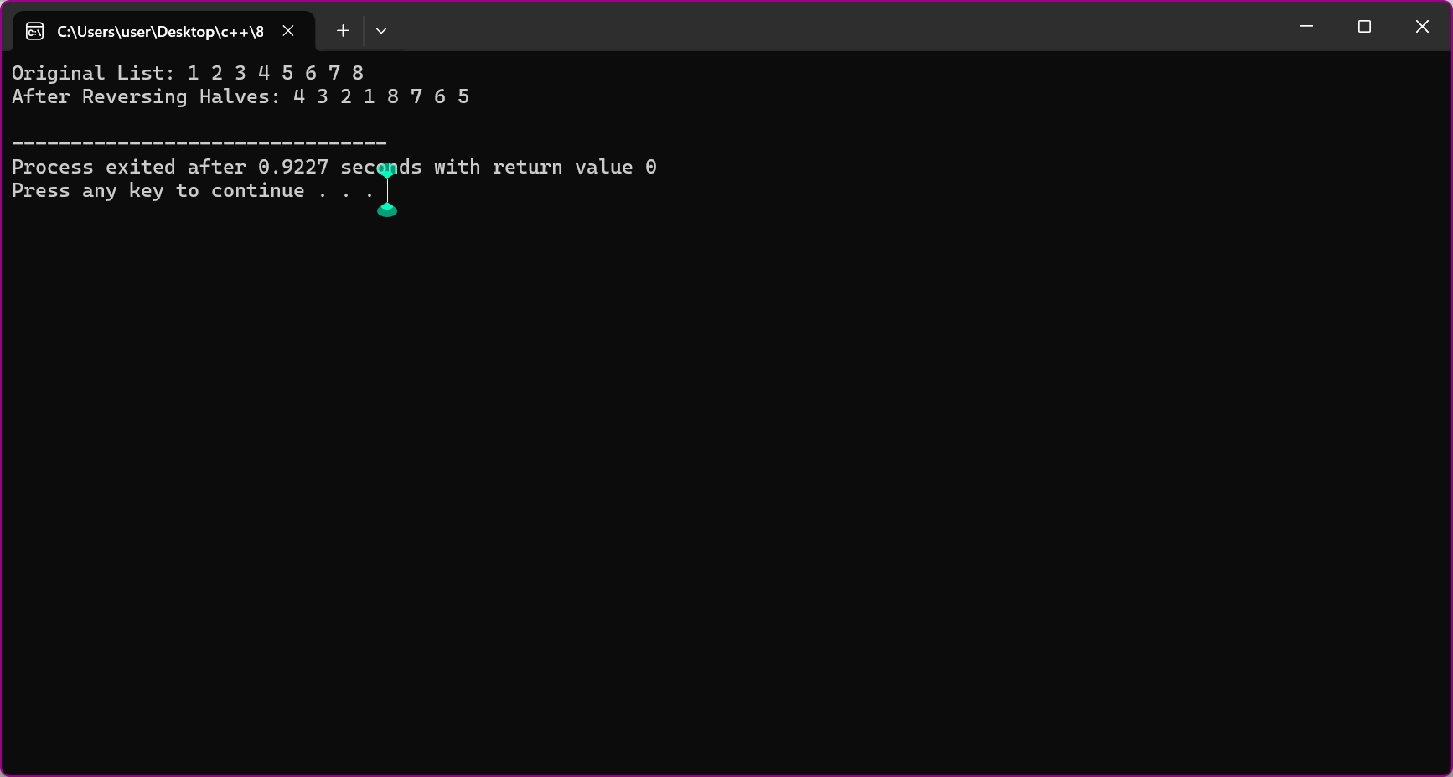
LAB task 8
#include <iostream>
using namespace std;

struct Node
{
int data;
Node* next;
};

void insertEnd(Node*& head, int value)
{
Node* newNode = new Node;
newNode->data = value;
newNode->next = NULL;

if (head == NULL)
{
head = newNode;
return;
}

Node* temp = head;

while (temp->next != NULL)
{
temp = temp->next;
}

temp->next = newNode;
}

void display(Node* head)
{
while (head != NULL)
{
cout << head->data << " ";
head = head->next;
}

cout << endl;
}

void removeDuplicates(Node* head)
{
Node* current = head;

while (current != NULL)
{
Node* previous = current;
Node* temp = current->next;

while (temp != NULL)
{
if (temp->data == current->data)
{
previous->next = temp->next;
delete temp;
temp = previous->next;
}
else
{
previous = temp;
temp = temp->next;
}
}

current = current->next;
}
}

int main()
{
Node* head = NULL;
insertEnd(head, 101);
insertEnd(head, 202);
insertEnd(head, 101);
insertEnd(head, 303);
insertEnd(head, 202);
insertEnd(head, 404);
cout << "Original List: ";
display(head);
removeDuplicates(head);
cout << "After Removing Duplicates: ";
display(head);
return 0;
}

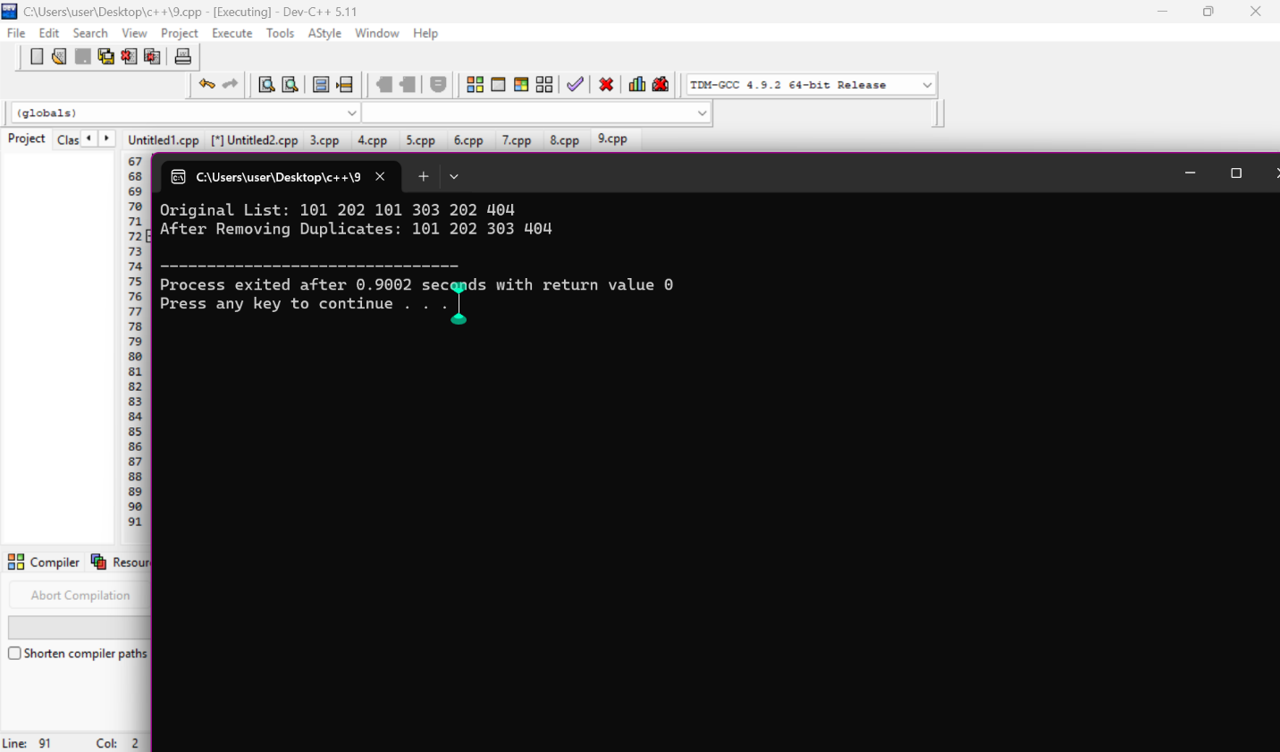
lab task 9
Lab#include <iostream>
using namespace std;
struct Node
{
int data;
Node* next;
};
void insertEnd(Node*& head, int value)
{
Node* newNode = new Node;
newNode->data = value;
newNode->next = NULL;
if (head == NULL)
{
head = newNode;
return;
}
Node* temp = head;
while (temp->next != NULL)
{
temp = temp->next;
}

temp->next = newNode;
}

void display(Node* head)
{
while (head != NULL)
{
cout << head->data << " ";
head = head->next;
}

cout << endl;
}

void deleteAll(Node*& head, int value)
{
while (head != NULL && head->data == value)
{
Node* temp = head;
head = head->next;
delete temp;
}
Node* current = head;
while (current != NULL && current->next != NULL)
{
if (current->next->data == value)
{
Node* temp = current->next;
current->next = temp->next;
delete temp;
}
else
{
current = current->next;
}
}
}

int main()
{
Node* head = NULL;

insertEnd(head, 10);
insertEnd(head, 20);
insertEnd(head, 30);
insertEnd(head, 20);
insertEnd(head, 40);
insertEnd(head, 20);
insertEnd(head, 50);

cout << "Original List: ";
display(head);
int id = 20;
deleteAll(head, id);

cout << "After Deleting " << id << ": ";
display(head);

return 0;
}
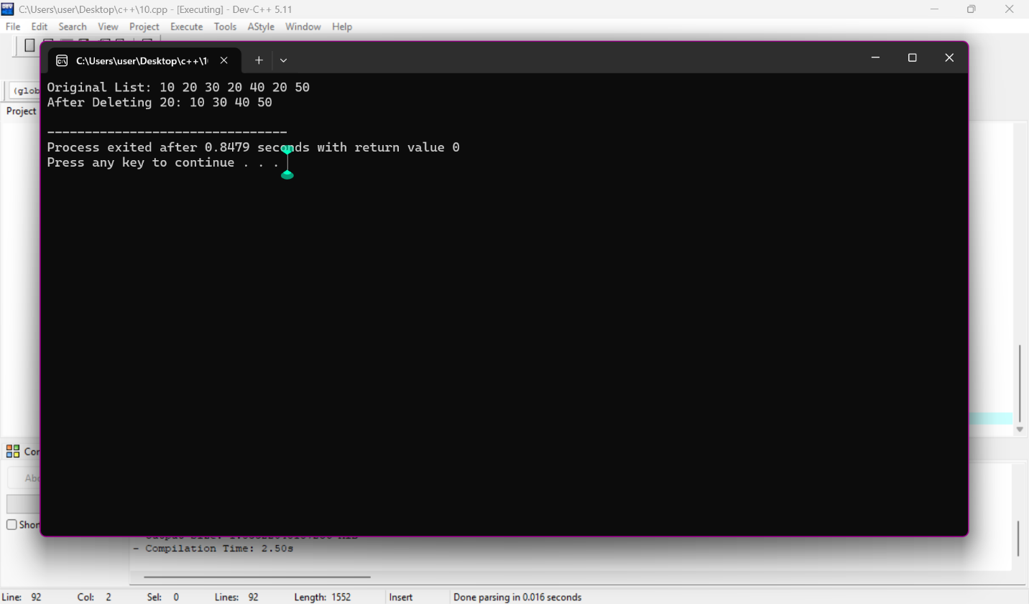
Lab task 10
#include <iostream>
using namespace std;

struct Node
{
int data;
Node* next;
};

void insertEnd(Node*& head, int value)
{
Node* newNode = new Node;
newNode->data = value;
newNode->next = NULL;

if (head == NULL)
{
head = newNode;
return;
}

Node* temp = head;

while (temp->next != NULL)
{
temp = temp->next;
}

temp->next = newNode;
}

void display(Node* head)
{
while (head != NULL)
{
cout << head->data << " ";

head = head->next;
}

cout << endl;
}

void swapPairs(Node*& head)
{
if (head == NULL || head->next == NULL)
return;

Node* previous = NULL;
Node* current = head;

head = head->next;

while (current != NULL && current->next != NULL)
{
Node* second = current->next;
Node* nextPair = second->next;

second->next = current;
current->next = nextPair;

if (previous != NULL)
{
previous->next = second;
}

previous = current;
current = nextPair;
}
}

int main()
{
Node* head = NULL;

insertEnd(head, 1);
insertEnd(head, 2);
insertEnd(head, 3);
insertEnd(head, 4);
insertEnd(head, 5);
insertEnd(head, 6);

cout << "Original List: ";
display(head);

swapPairs(head);

cout << "After Pairwise Swapping: ";
display(head);

return 0;
}
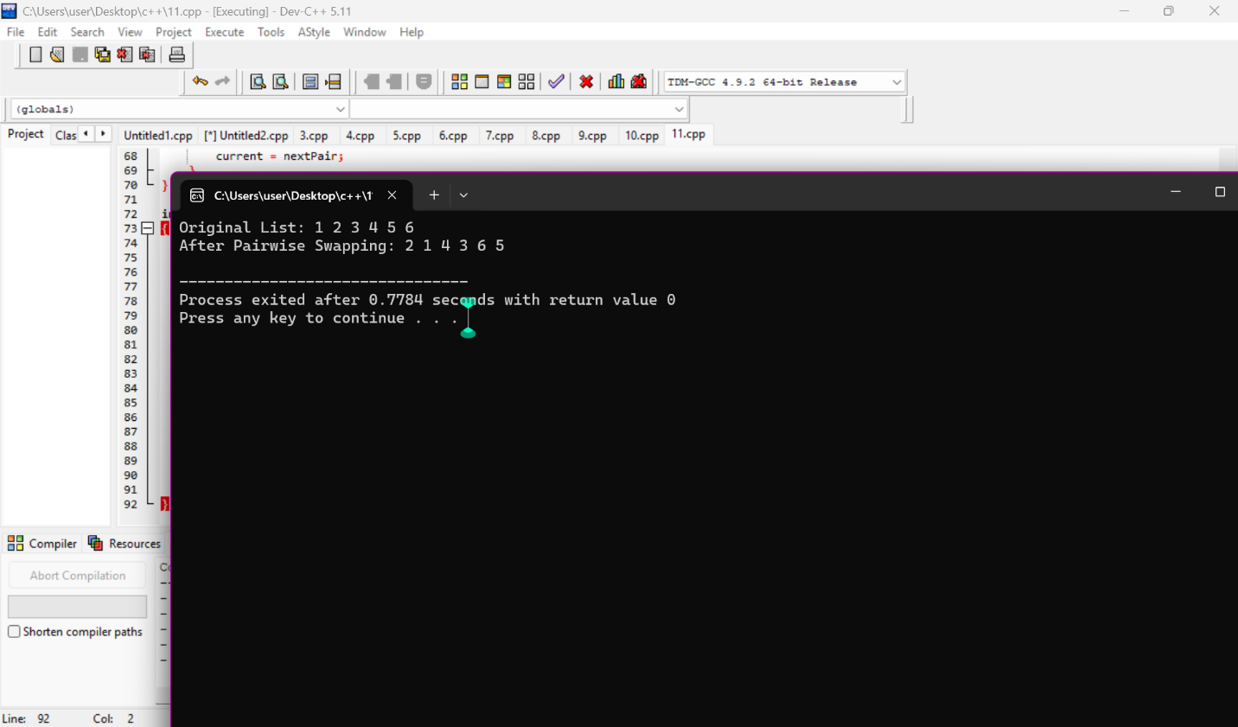
Lab task 11
Double link list
#include <iostream>
using namespace std;

struct Node
{
string data;
Node* prev;
Node* next;
};

void insertEnd(Node*& head, Node*& tail, string value)
{
Node* newNode = new Node;

newNode->data = value;
newNode->prev = NULL;
newNode->next = NULL;

if (head == NULL)
{
head = tail = newNode;
return;
}

tail->next = newNode;
newNode->prev = tail;
tail = newNode;
}

void display(Node* head)
{
Node* temp = head;

while (temp != NULL)
{
cout << temp->data;

if (temp->next != NULL)
cout << " <-> ";

temp = temp->next;
}
cout << endl;
}
void swapFromBothEnds(Node* head, Node* tail)
{
Node* left = head;
Node* right = tail;
while (left != right && left->prev != right)
{
string temp = left->data;
left->data = right->data;
right->data = temp;
left = left->next;
right = right->prev;
}
}
int main()
{
Node* head = NULL;
Node* tail = NULL;

insertEnd(head, tail, "Alice");
insertEnd(head, tail, "Bob");
insertEnd(head, tail, "Charlie");
insertEnd(head, tail, "Dana");
insertEnd(head, tail, "Eva");
insertEnd(head, tail, "Frank");
cout << "Original List:" << endl;
display(head);
swapFromBothEnds(head, tail);
cout << "After Swapping:" << endl;
display(head);
return 0;
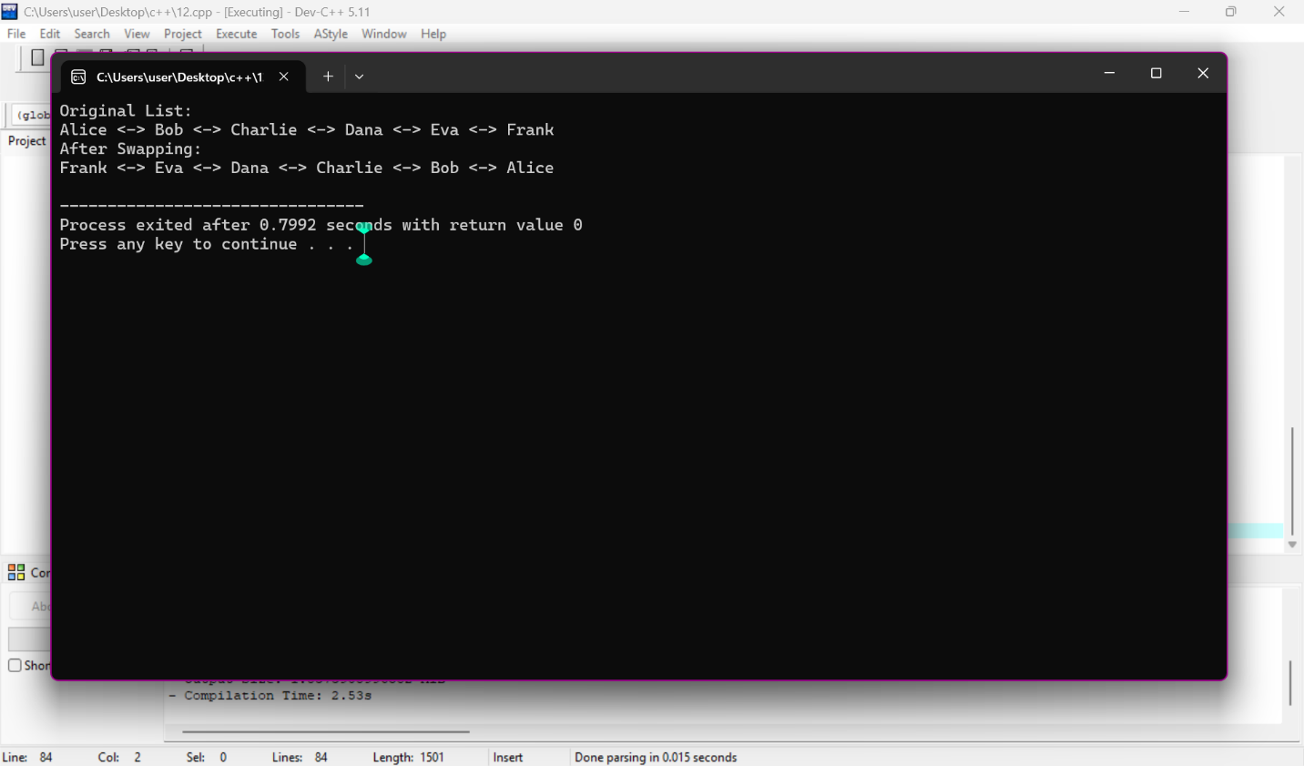
}

Lab task 12
#include <iostream>
using namespace std;

struct Node
{
string song;
Node* prev;
Node* next;
};

void addSong(Node*& head, Node*& tail, string song)
{
Node* newNode = new Node;

newNode->song = song;
newNode->prev = NULL;
newNode->next = NULL;

if (head == NULL)
{
head = tail = newNode;
return;
}

tail->next = newNode;
newNode->prev = tail;
tail = newNode;
}
void displayForward(Node* head)
{
Node* temp = head;
cout << "Songs Forward:" << endl;
while (temp != NULL)
{
cout << temp->song << endl;
temp = temp->next;
}
}
void displayBackward(Node* tail)
{
Node* temp = tail;
cout << "Songs Backward:" << endl;
while (temp != NULL)
{
cout << temp->song << endl;
temp = temp->prev;
}
}
int main()
{
Node* head = NULL;
Node* tail = NULL;
addSong(head, tail, "Song 1");
addSong(head, tail, "Song 2");
addSong(head, tail, "Song 3");
addSong(head, tail, "Song 4");
displayForward(head);
cout << endl;
displayBackward(tail);
return 0;
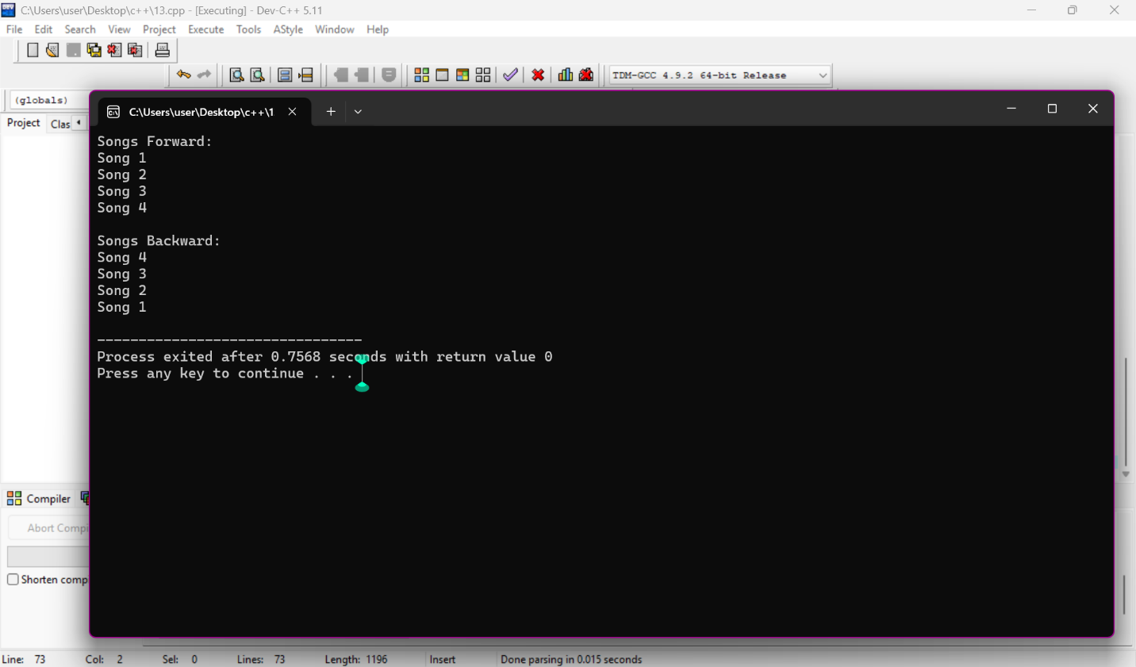
}

Lab task 13
#include <iostream>
using namespace std;
struct Item
{
string name;
Item* next;
};
struct Section
{
string name;
Item* itemHead;
Section* next;
};
struct Store
{
string name;
Section* sectionHead;
Store* next;
};
// Add a new store
void addStore(Store*& head, string storeName)
{
Store* newStore = new Store;
newStore->name = storeName;
newStore->sectionHead = NULL;
newStore->next = NULL;
if (head == NULL)
{
head = newStore;
return;
}

Store* temp = head;
while (temp->next != NULL)
{
temp = temp->next;
}
temp->next = newStore;
}
// Find store
Store* findStore(Store* head, string storeName)
{
Store* temp = head;
while (temp != NULL)
{
if (temp->name == storeName)
return temp;
temp = temp->next;
}
return NULL;
}
// Add section to store
void addSection(Store* store, string sectionName)
{
if (store == NULL)
{
cout << "Store not found." << endl;
return;
}
Section* newSection = new Section;
newSection->name = sectionName;
newSection->itemHead = NULL;
newSection->next = NULL;
if (store->sectionHead == NULL)
{
store->sectionHead = newSection;
return;
}
Section* temp = store->sectionHead;
while (temp->next != NULL)
{
temp = temp->next;
}
temp->next = newSection;
}
// Find section
Section* findSection(Store* store, string sectionName)
{
if (store == NULL)
return NULL;
Section* temp = store->sectionHead;
while (temp != NULL)
{
if (temp->name == sectionName)
return temp;
temp = temp->next;
}
return NULL;
}

// Add item
void addItem(Store* store, string sectionName, string itemName)
{
Section* section = findSection(store, sectionName);

if (section == NULL)
{
cout << "Section not found." << endl;
return;
}
Item* newItem = new Item;

newItem->name = itemName;
newItem->next = NULL;

if (section->itemHead == NULL)
{
section->itemHead = newItem;
return;
}

Item* temp = section->itemHead;

while (temp->next != NULL)
{
temp = temp->next;
}

temp->next = newItem;
}

// Remove item
void removeItem(Store* store, string sectionName, string itemName)
{
Section* section = findSection(store, sectionName);

if (section == NULL)
{
cout << "Section not found." << endl;
return;
}

Item* current = section->itemHead;
Item* previous = NULL;

while (current != NULL)
{
if (current->name == itemName)
{
if (previous == NULL)
{
section->itemHead = current->next;
}
else
{
previous->next = current->next;
}

delete current;

cout << "Item removed." << endl;
return;
}

previous = current;
current = current->next;
}
cout << "Item not found." << endl;
}
// Display items of a section
void displaySectionItems(Store* store, string sectionName)
{
Section* section = findSection(store, sectionName);
if (section == NULL)
{
cout << "Section not found." << endl;
return;
}

cout << "Items in " << sectionName << ":" << endl;
Item* temp = section->itemHead;
while (temp != NULL)
{
cout << temp->name << endl;
temp = temp->next;
}
}
// Display all items of a store
void displayStore(Store* store)
{
if (store == NULL)
{
cout << "Store not found." << endl;
return;
}
cout << "Store: " << store->name << endl;
Section* section = store->sectionHead;

while (section != NULL)
{
cout << "\nSection: " << section->name << endl;
Item* item = section->itemHead;
while (item != NULL)
{
cout << " " << item->name << endl;
item = item->next;
}
section = section->next;
}
}
int main()
{
Store* stores = NULL;

// Add stores
addStore(stores, "Store A");
addStore(stores, "Store B");

// Find Store A
Store* storeA = findStore(stores, "Store A");

// Add sections
addSection(storeA, "Grocery");
addSection(storeA, "Toys");
addSection(storeA, "Fruits");
// Add items
addItem(storeA, "Grocery", "Rice");
addItem(storeA, "Grocery", "Sugar");
addItem(storeA, "Grocery", "Flour");
addItem(storeA, "Toys", "Car");
addItem(storeA, "Toys", "Doll");
addItem(storeA, "Fruits", "Apple");
addItem(storeA, "Fruits", "Mango");
// Display section
displaySectionItems(storeA, "Grocery");
cout << endl;
// Display complete store
displayStore(storeA);
cout << endl;
// Remove item
removeItem(storeA, "Grocery", "Sugar");
cout << endl;
displayStore(storeA);
return 0;
}
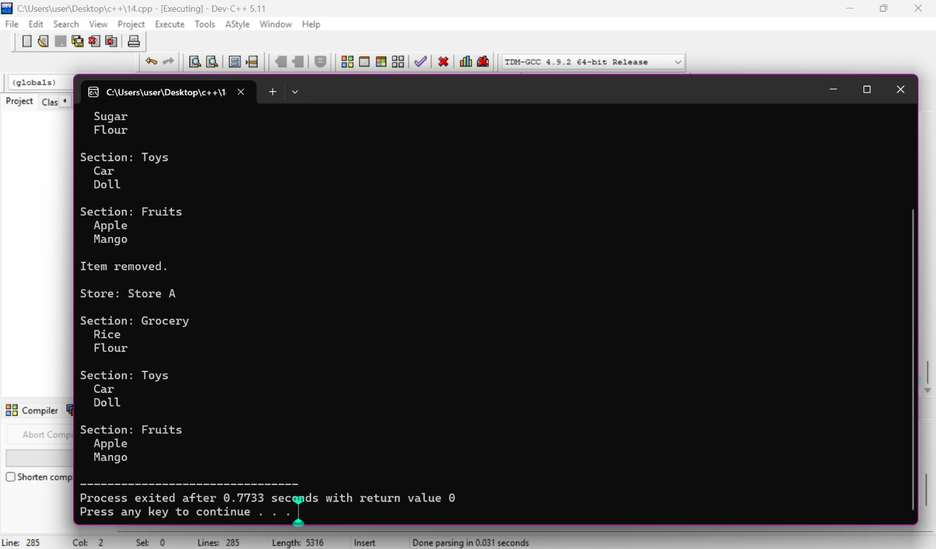
Lab task 14
#include <iostream>
using namespace std;

struct Node
{
int data;
Node* prev;
Node* next;
};

void insertEnd(Node*& head, Node*& tail, int value)
{
Node* newNode = new Node;

newNode->data = value;
newNode->prev = NULL;
newNode->next = NULL;

if (head == NULL)
{
head = tail = newNode;
return;
}

tail->next = newNode;
newNode->prev = tail;
tail = newNode;
}

void display(Node* head)
{
Node* temp = head;

while (temp != NULL)
{
cout << temp->data;

if (temp->next != NULL)
cout << " -> ";

temp = temp->next;
}

cout << endl;
}

void specialPattern(Node* head, Node* tail)
{
Node* left = head->next;
Node* right = tail->prev;

while (left != NULL && right != NULL && left != right)
{
int temp = left->data;
left->data = right->data;
right->data = temp;

left = left->next->next;
right = right->prev->prev;

if (left == NULL || right == NULL)
break;
}
}

int main()
{
Node* head = NULL;
Node* tail = NULL;

insertEnd(head, tail, 1);
insertEnd(head, tail, 2);
insertEnd(head, tail, 3);
insertEnd(head, tail, 4);
insertEnd(head, tail, 5);
insertEnd(head, tail, 6);
insertEnd(head, tail, 7);
insertEnd(head, tail, 8);
insertEnd(head, tail, 9);

cout << "Original List:" << endl;
display(head);

specialPattern(head, tail);

cout << "After Special Pattern:" << endl;
display(head);

return 0;
}
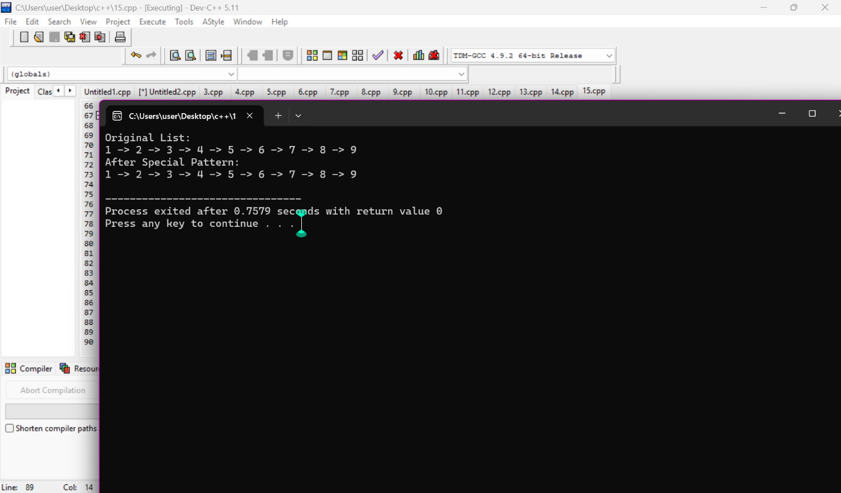
Lab task 15
#include <iostream>
using namespace std;

struct Node
{
int data;
Node* next;
};

void createList(Node*& head, Node*& tail, int n)
{
for (int i = 1; i <= n; i++)
{
Node* newNode = new Node;

newNode->data = i;
newNode->next = NULL;

if (head == NULL)
{
head = newNode;
tail = newNode;
newNode->next = head;
}
else
{
tail->next = newNode;
tail = newNode;
tail->next = head;
}
}
}

int josephus(int n, int m)
{
Node* head = NULL;
Node* tail = NULL;

createList(head, tail, n);

Node* current = head;
Node* previous = tail;

while (current->next != current)
{
// Skip M-1 persons
for (int i = 1; i < m; i++)
{
previous = current;
current = current->next;
}

// Kill current person
previous->next = current->next;

Node* temp = current;
current = current->next;

delete temp;
}

int survivor = current->data;

delete current;

return survivor;
}

int main()
{
int n, m;

cout << "Enter number of persons: ";
cin >> n;

cout << "Enter M: ";
cin >> m;
int survivor = josephus(n, m);
cout << "Survivor is person: " << survivor << endl;
return 0;
}
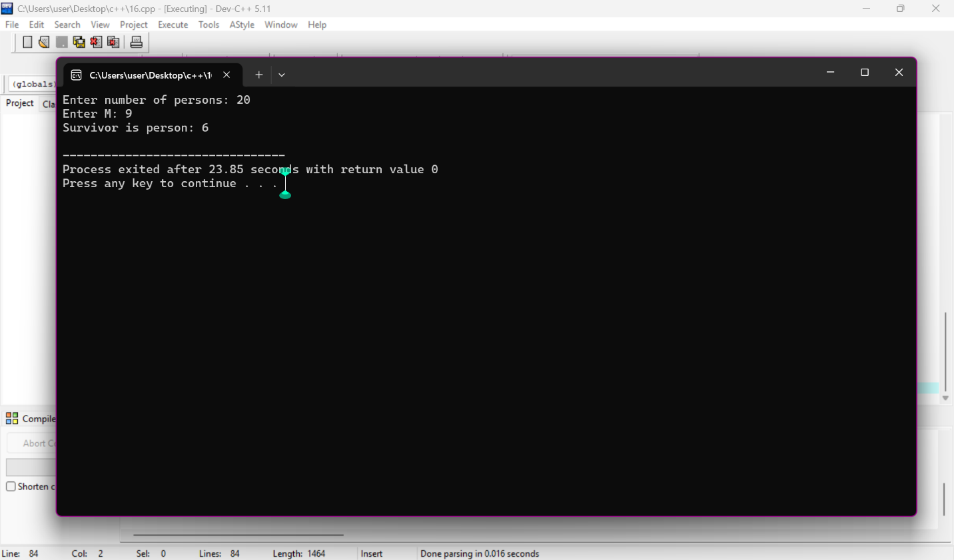
Lab task16
#include <iostream>
using namespace std;

struct Task
{
string name;
int priority;
string status;

Task* next;
};

// Add task at the end
void addTask(Task*& head, Task*& tail,
string name, int priority, string status)
{
Task* newTask = new Task;

newTask->name = name;
newTask->priority = priority;
newTask->status = status;

if (head == NULL)
{
head = newTask;
tail = newTask;

newTask->next = head;
}
else
{
tail->next = newTask;
tail = newTask;

tail->next = head;
}
}

// Remove task by name
void removeTask(Task*& head, Task*& tail, string name)
{
if (head == NULL)
{
cout << "Task list is empty." << endl;
return;
}

Task* current = head;
Task* previous = tail;

do
{
if (current->name == name)
{
// Only one task
if (current == head && current == tail)
{
delete current;

head = NULL;
tail = NULL;

cout << "Task removed." << endl;
return;
}

// Remove head
if (current == head)
{
head = head->next;
tail->next = head;

delete current;

cout << "Task removed." << endl;
return;
}

// Remove tail
if (current == tail)
{
tail = previous;
tail->next = head;

delete current;

cout << "Task removed." << endl;
return;
}

// Remove middle node
previous->next = current->next;

delete current;

cout << "Task removed." << endl;
return;
}

previous = current;
current = current->next;

} while (current != head);

cout << "Task not found." << endl;
}

// Get next pending task
Task* getNextTask(Task*& current)
{
if (current == NULL)
return NULL;

Task* start = current;

do
{
current = current->next;

if (current->status == "pending")
{
return current;
}

} while (current != start);

return NULL;
}

// Display all tasks
void displayTasks(Task* head)
{
if (head == NULL)
{
cout << "No tasks available." << endl;
return;
}

Task* current = head;

do
{
cout << "Task Name: " << current->name << endl;
cout << "Priority: " << current->priority << endl;
cout << "Status: " << current->status << endl;
cout << "-------------------" << endl;

current = current->next;

} while (current != head);
}

// Update task status
void updateStatus(Task* head, string name, string newStatus)
{
if (head == NULL)
{
cout << "Task list is empty." << endl;
return;
}

Task* current = head;

do
{
if (current->name == name)
{
current->status = newStatus;

cout << "Updated Task: " << current->name << endl;
cout << "New Status: " << current->status << endl;

return;
}

current = current->next;

} while (current != head);

cout << "Task not found." << endl;
}

int main()
{
Task* head = NULL;
Task* tail = NULL;

// Add tasks
addTask(head, tail, "Task1", 1, "pending");
addTask(head, tail, "Task2", 2, "pending");
addTask(head, tail, "Task3", 3, "completed");
addTask(head, tail, "Task4", 1, "pending");

// Display all tasks
cout << "===== ALL TASKS =====" << endl;

displayTasks(head);

// Update task status
cout << "\n===== UPDATE STATUS =====" << endl;

updateStatus(head, "Task1", "completed");

// Get next pending task
cout << "\n===== NEXT PENDING TASK =====" << endl;

Task* current = head;

Task* nextTask = getNextTask(current);

if (nextTask != NULL)
{
cout << "Next Task: " << nextTask->name << endl;
cout << "Priority: " << nextTask->priority << endl;
cout << "Status: " << nextTask->status << endl;
}
else
{
cout << "No pending task available." << endl;
}

// Remove a task
cout << "\n===== REMOVE TASK =====" << endl;
removeTask(head, tail, "Task3");
// Display after removal
cout << "\n===== TASKS AFTER REMOVAL =====" << endl;
displayTasks(head);
return 0;
}
